1.rejected sheets shown still in staff labour and progress. rejected daily sheets should not be visible with active ones as same right becuase no use , search and follwo other system standerds .

2. job scenarios labour , staff , technicians should be picked up from existinf staff . we have a technisians master form but what should happened is we should have a place to add employyes as users to this system and giving there roles . check before we already satisfied that .
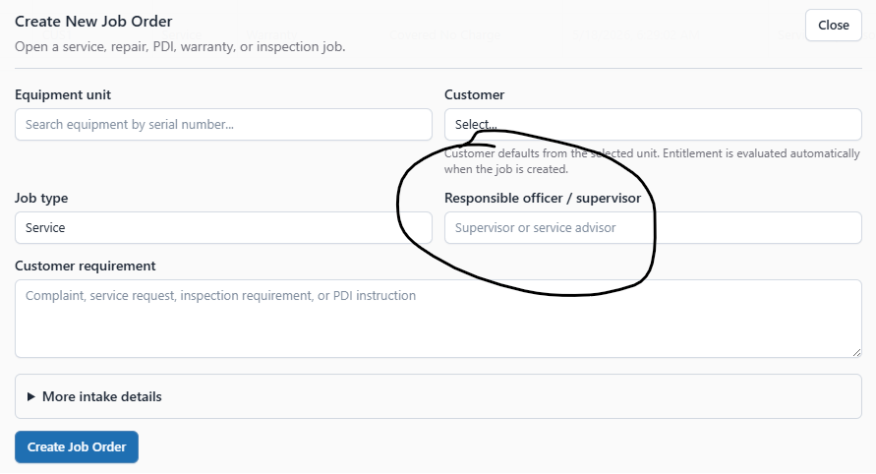

3. If we add wrong or miss anything to add in as service intervals, bext service date , next repaire date we cannot add in Equipment Units .

4.The job sheet form lacks the standard modal dialog for creation in other job related forms .also with Hours
0.00 rate 20 billing 25 for two hours and approved but still shows aproved labour costs 0.00 . pending approval cost 20.00 and Approved Billable Labor 20.00. even approved still shows submitted .
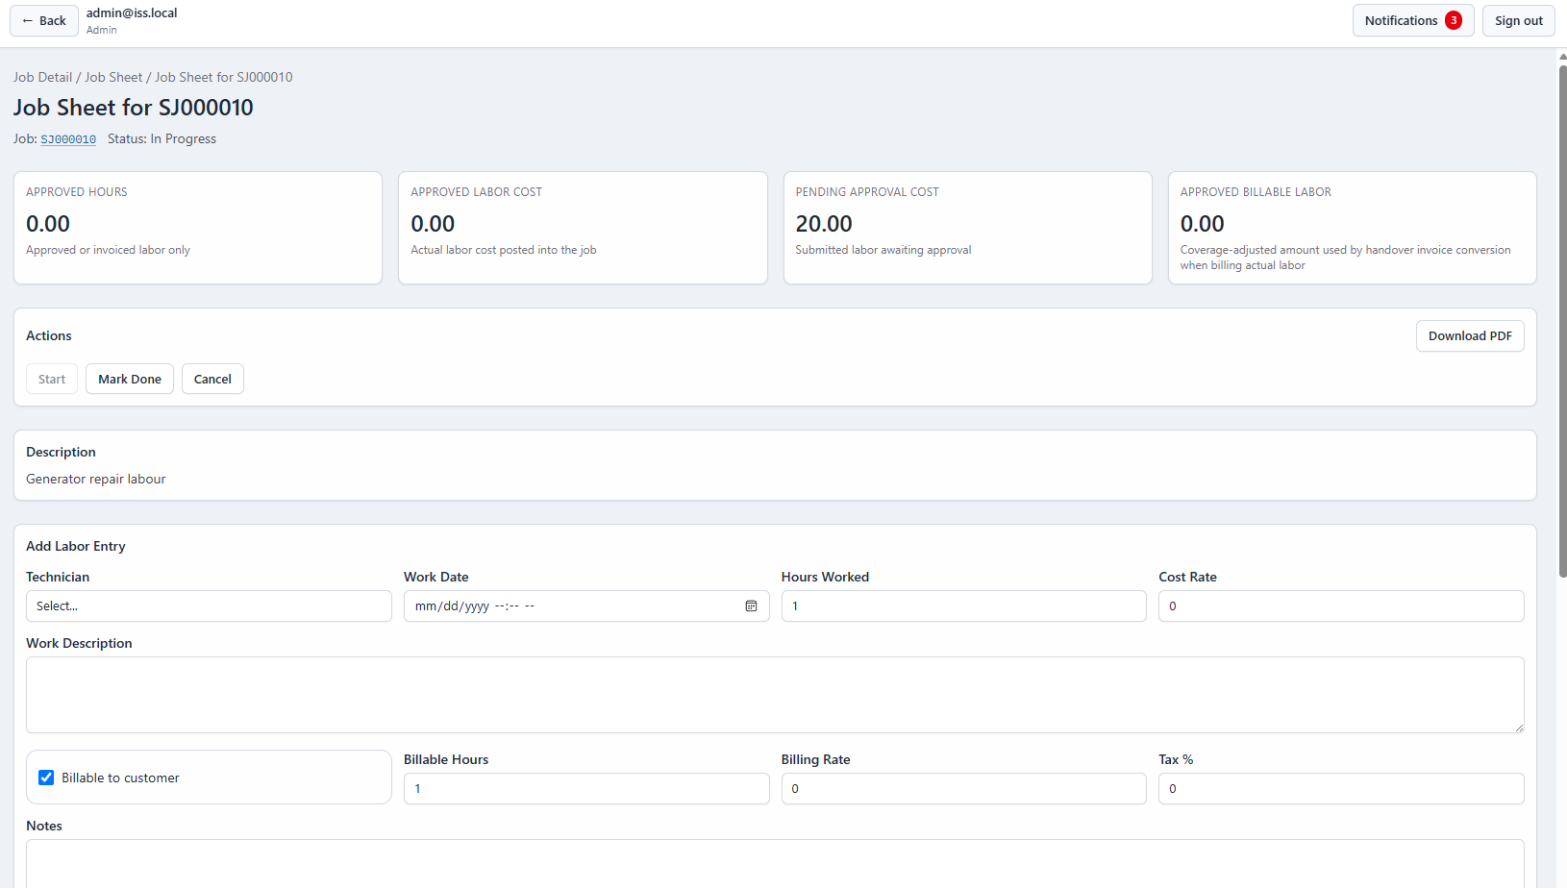
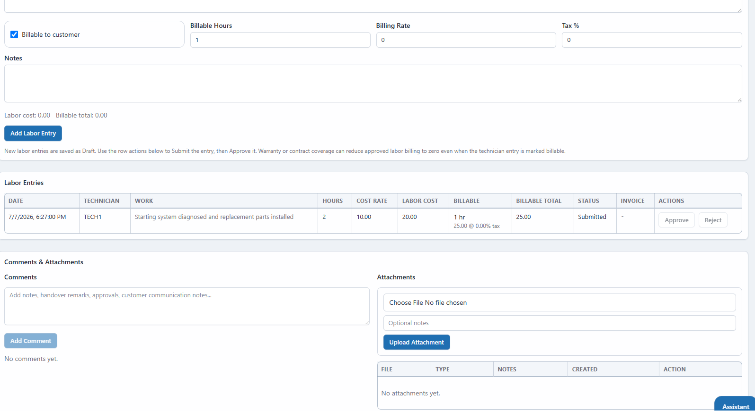

MRN also lacks Job like model dialog create /edit

